2nd Semester 2023-2024 Health Assignments

Do Now: 4/16/24
(Remember this should be on a new sheet in the classwork sections of your notebook and all of the Do Now’s for this week should be on one page (the front filled up before the back is used) in order to get credit for them all.
- What is your SMART goal for this class
- What is your current grade in this class?
- Are on track to meet your SMART goal for this class?
Class work: 4/16/24
- Heading: Reflection of My Qualities
- For 1-7 on page 119,
  - Write the number
  - Write the heading next to the number
  - List 3 responses that apply to you under each number/heading
4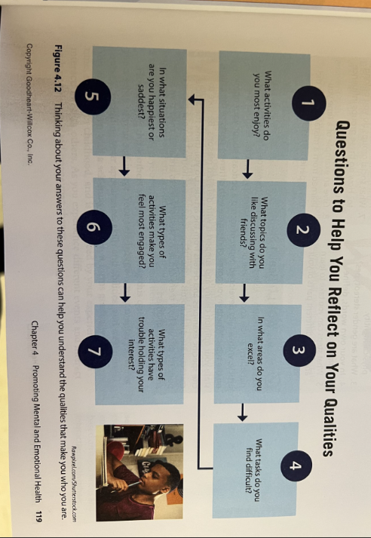

Spring Break: 4/8-15/24-P

4/5/24
4/4/24
4/3/24
4/2/24
4/1/24
**Plant Care & Journal prior to spring Break & missing assignments**

Do Now:3/27-29/24
- List three ways you can demonstrate self-respect
Classwork:
create Brochure for lesson 7 & 8 including the major topics in the brochure along with best practices
*Be mindful of the specific location for all information* Use Information from CTB workbook:

CTB Brochure: Lesson 8 & 9: Information provided that is not from CTB book will not receive credit.
Requirements: | Location | Points | Chunk  (should be done)
I. Title Page: Title: Overcoming the Pressure & Being Assertive-Name, Period, Image relevant to topic | Front Cover | 10 | March 27
II. 3 Steps for Overcoming Pressure: page 54 in CTB book | Far Left Page at top | 10 | March 27
III. 3 Steps for Setting YOUR Boundaries: page 54 | Left Page Middle  (same page as above) | 10 | March 28
IV. Preventing Sexual Violence: Consent is : Info from page 56 (1 fact from 1-4 on page 56 & all information in box on bottom of page 56) | Middle Page at top | 20 | March 28
V. Respect: 2 bullet points: How is it relevant to overcoming Pressure: use page 58 to assist you | Middle Page at Bottom | 10 | March 29
VI. Developing Assertiveness Skills page 61 (3 steps and the info in black to the right of the steps) | Far Right Page at top | 10 | March 29
VII. 3 facts about courage on page 66 | Far Right Page at bottom | 10 | March 29
VIII. Image on all three pages | Left, middle, and right | 20 | March 27-29
Total |  | 100pts | Due: March 29  (will take until April 2)
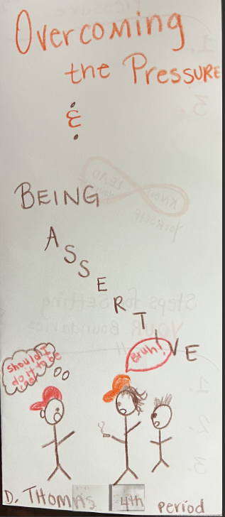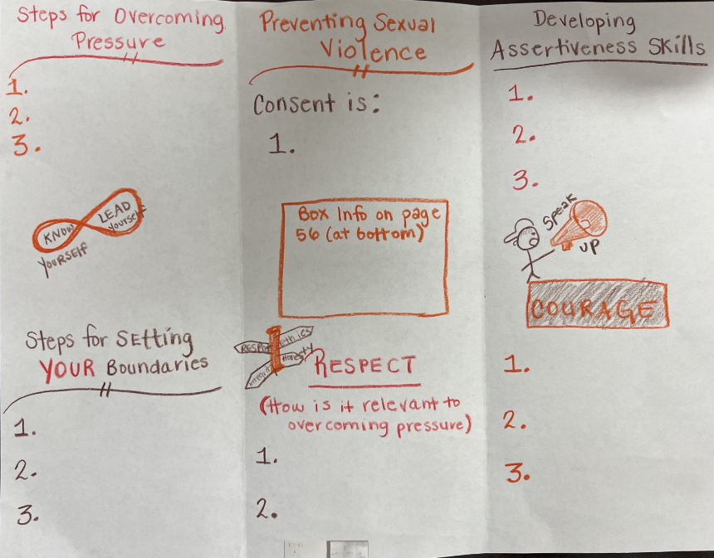

Closing: teacher touch on key points

Do Now: 3/26/24
- List two things you learned/recall from the emotional trap discussion on yesterday
Classwork: 3/26/24
- KIM chart:
  - Honesty
  - Self-respect
K. key term | I. info (3 bullet points) | M. memory clue
honesty | *  *  *
Self-respect | *  *  *

- Page 38 (List top three values & role model section)
- Page 39

Classwork: 3/25/24: Emotional Trap Portion below
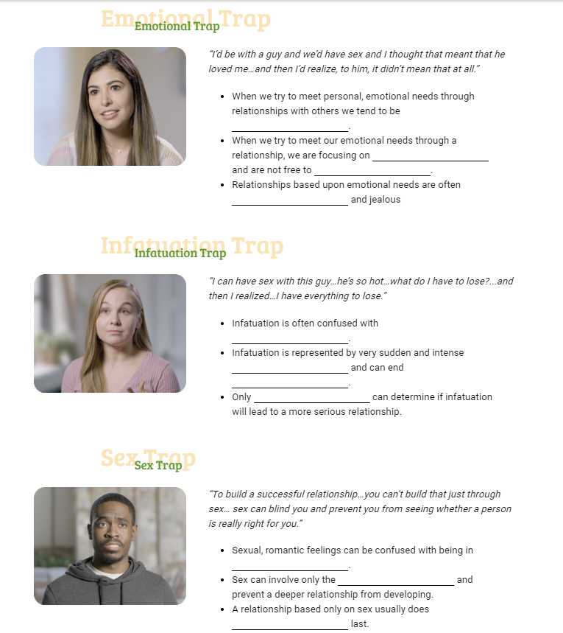

Classwork: 3/21-22/24
- Review of Organizer Expectations
- Same as previous day Complete Choosing the Best Organizer for Lesson 3 & 4

Do Now: 3/20/24
N/A
Classwork:3/20/24
1.Review of Do Now & Class expectations for receiving full credit
2.CTB Lesson 3 & 4 One page organizer
1.Baby Budget: 40pts follow workbook outline
2.Top 2 Methods for reducing pregnancy risk-20pts
3. 2 facts from How STD’s are spread section on page 27-20pts
4. 2 facts about 4 STDs on pages 28 & 29-40 points (name the STDs specifically)
5.100% protection practice against STDS-20pts
6. 2 images-20pts
7.Followed outline & expectations-40pts-200 total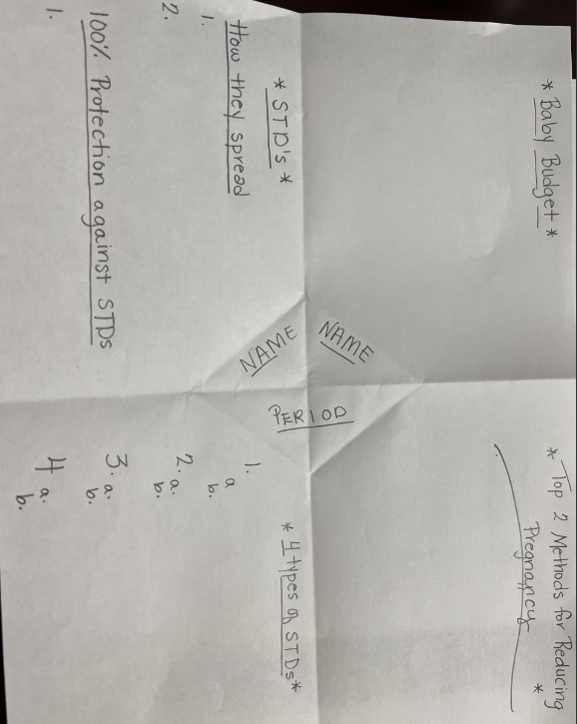

Do Now: 3/19/24
- Close Read Determination Section of CTB

Classwork:3/19/24
1.Determination Read together & write 5 sentence summary explaining what this reading has to do with determination and how you can use this in your life.

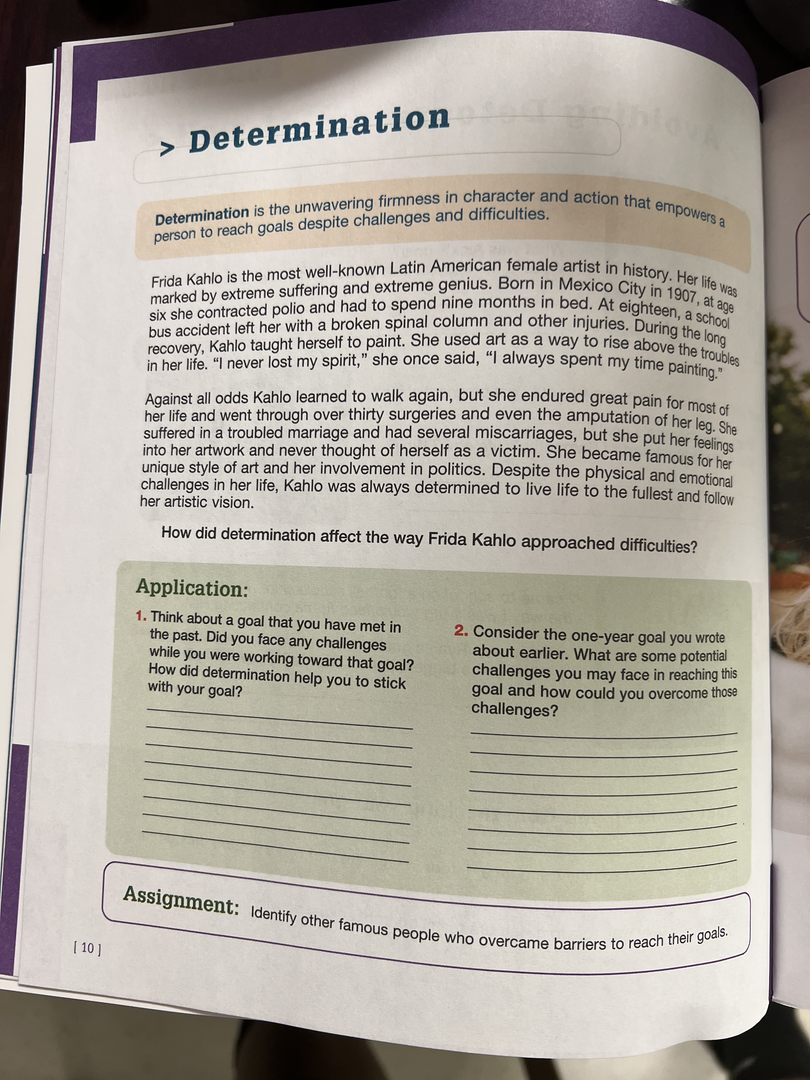
- Complete number 2 on page 10 above.
  - List at least three challenges
  - List a method for overcoming each
- Complete the top of page 13 below
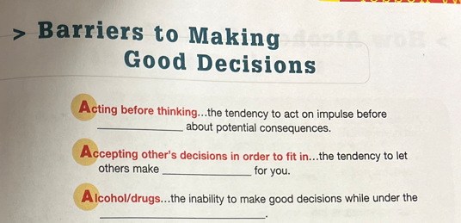

Classwork: 3/18/24 Active Listening & Personal Goals
- List three keys to active listening
- In two sentences, explain why active listening is essential to relationships.
Classwork: Personal Goal Setting (the heading)
Complete the Personal Goal Section on Page 8. Make sure to include the heading and information you see on the page as well as the number. Your paper should have everything you see in the sections in addition to your responses.
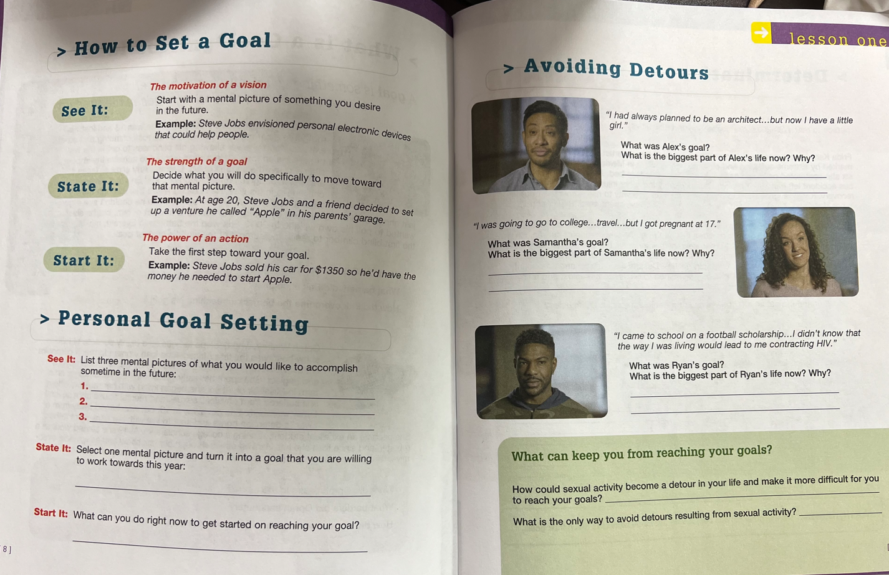

Do Now: 3/20/24
- If using teacher page click the link below
  - https://goldeneye.jeanakins.com/choosing-the-best/survey-home
- Go to Launch pad Follow the steps below
- click on the Choosing the Best ICON
- If you cannot find the Icon
  - Students go to: ChoosingtheBestOnline.com
    - LOGIN is School Email Address.
    - PASSWORD is their first name lower case 01 ex..(clifton01). This has to be the name on the roster. NO NICKNAMES etc..
- The survey code is CTB2324.
- Survey instructions
  - click on Entry-Survey and fill in preliminary information following the instructions.
  - answer all the survey questions
  - click “done” when finished

Continue: Create Vocab KIM chart for the 1.Determination 2. Wisdom
K | I | M
Determination
Wisdom

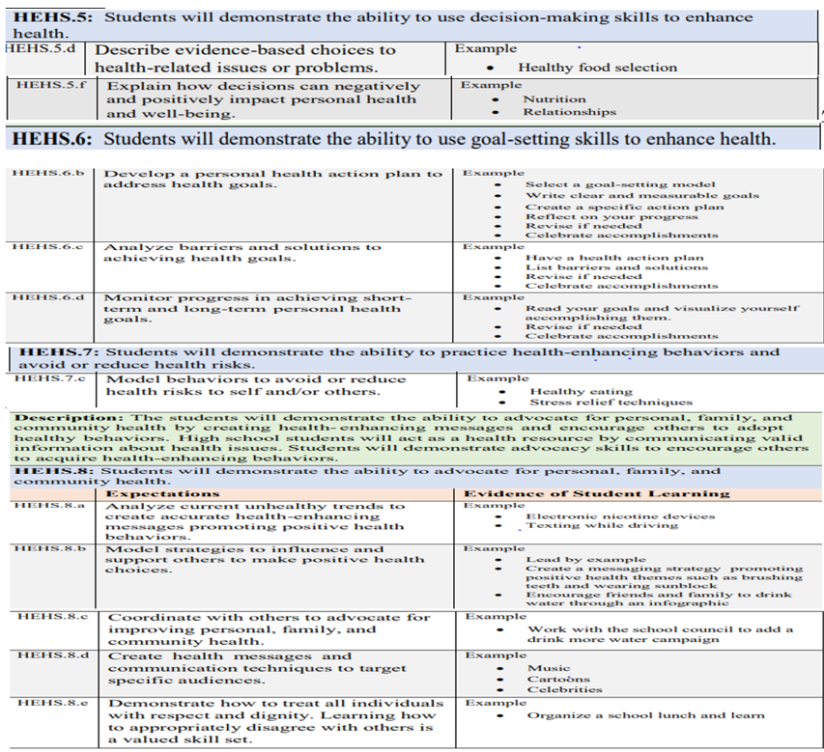

March 25th -29th Inside Out Movie

March 18th -22nd

Learning Target:
- I can define community health, community resources, environmental justice, public health, and world health and food deserts
- I can identity community resources

Success Criteria:
- I can advocate for community health by identifying and creating community resources (vegetable, fruit & herb garden)
- I can follow the steps for maintaining the wellness of herb & vegetable plants
- I can create a brochure/flyer for faculty & staff to choose to purchase and/or use the “fruits” of our labor from the “Health Garden”
- Create a sign for the health garden

Do Now: March 19
Login to Quizziz
Classwork: March 19
ADAP Assessment
Use remainder of time to complete study guide
Do Now:March 15
- What was your classwork assignment from the previous day?
Classwork: March 15
-Write questions & answer for study guide questions 9-16
-Review of study guide

March
Do Now: March 14
- List three things you know about ADAP
Classwork: March 14
Write Question & answer for study guide questions 1-8
ADAP Study Guide
Make sure you write the question and answer, provide headings for each questions, or restate the questions with the answers for FULL CREDIT.
TADRA and Traffic Laws and Safe Driving
- What does the acronym TADRA represent?
- What is the classification for Provisional license?
- List 2 requirements for those 16 years of age to obtain a Provisional License?
- With an Instructional Permit (Class CP) when are you able to operate a Class C vehicle?
- What are the hours in which a holder of a Class D license unable to drive?
- With a Provisional License (Class D) who can ride with you during the first 6 months?
- What are the consequences for refusing a drug/alcohol test?
- (Fill in the blank) Any driver under age 18 who holds a Class D license or a learner’s permit is prohibited from using ____________________.
- What is the leading cause of teen in the U.S.?
- How much does the risk of a fatal crash increase with a teen driver having two or more peer passengers?
- What is the most widely used drug in the world?
- List 4 long term effects of alcohol misuse.
- Fill in blank. BAC stands for _________ ___________ _____________
- Fill in blank. It is illegal for those 21 or younger to drive with a BAC of ________ or greater.
- List 4 drugs and 1 effect they have on the body (1 effect for each drug)
- Why is it not safe to drink and drive?
March 13
Do Now: March 13
Copy what you see below:
ADAP Learning Targets
1.I can define what TADRA represents
2.I can explain the purpose of TADRA
3. I can list the requirements for students drivers
What do the following stand for:
a.TADRA
b.ADAP
c.OTC
d.DUI

Classwork: March 13
Classwork: Ch.2 One pager in notebook
Create One pager on ch.2 of ADAP Manual: Traffic Laws & Safe Driving
Criteria | Possible Points
Chapter Title | 20 points
9 subheadings (highlighted & or underlined)-bold black | 50 points
5-7-word overview/importance of the specific safety practice or law (basically, do this for the subheadings from above) | 50 points
2 images relevant to chapter | 20pts
3 sentence summary of chapter | 20 pts
Name & class period at bottom | 20 pts
Total Possible | 180pts
*Extra credit for creating this chart and completing your own checklist of your one pager making sure you have each requirement* (if you check is incorrect then no credit will be earned) **

March 11: substitute
Do Now: March 12, 2024- none
Classwork: March 12
- Student DDS account setup
- Ch.1 ADAP one pager
-
Criteria: Title/heading for all content should be included in your one pager | Points | Point Earned
Name & Title | 20
TADRA-what it stands for | 10
TADRA-the purpose | 10
Graduated Driver’s License Process-the steps & a brief description of each | 30
3 Restrictions of Class D license | 15
Drinking Alcohol  -legal age to consume  -BAC defined  -BAC level that is considered DUI | 15
2 Images relevant to the information | 20
Total | 120
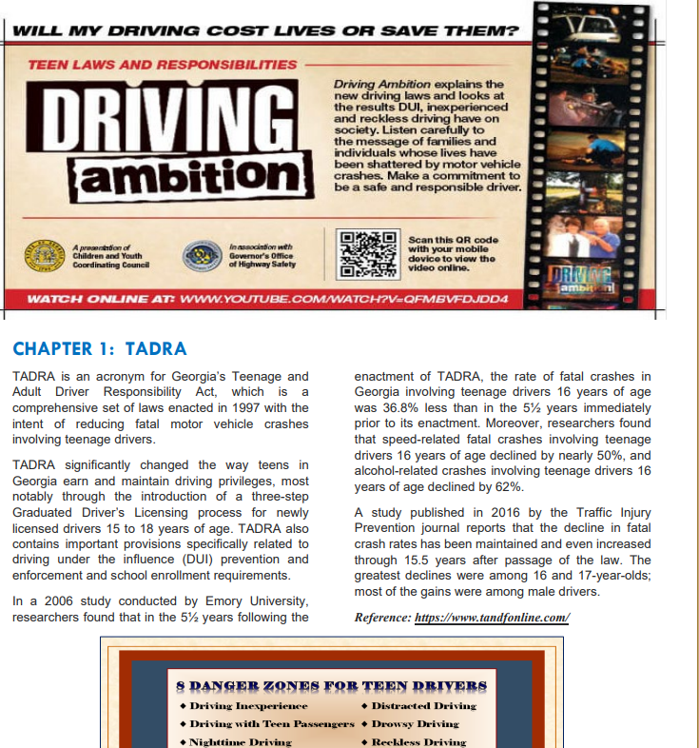
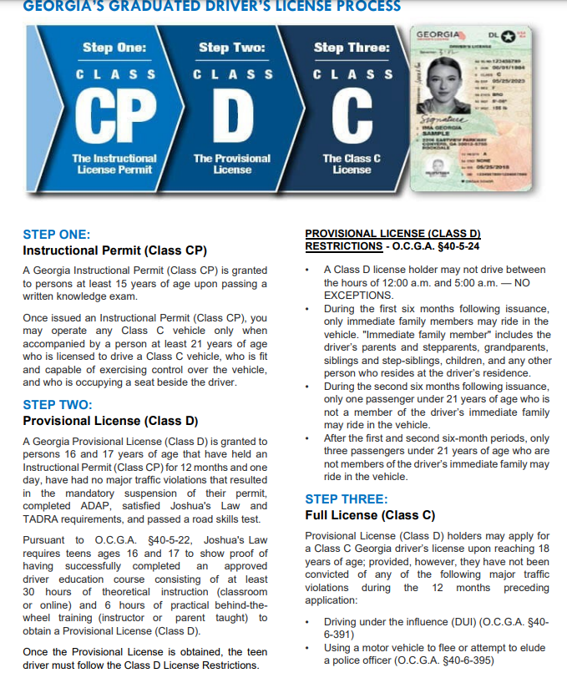
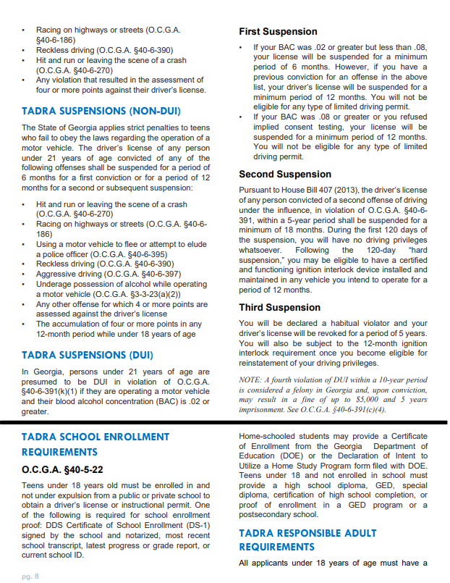
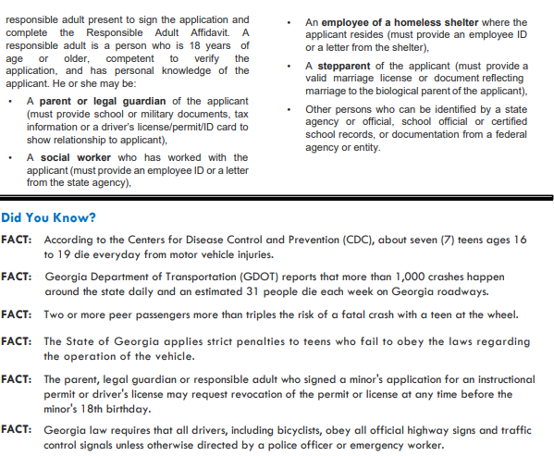

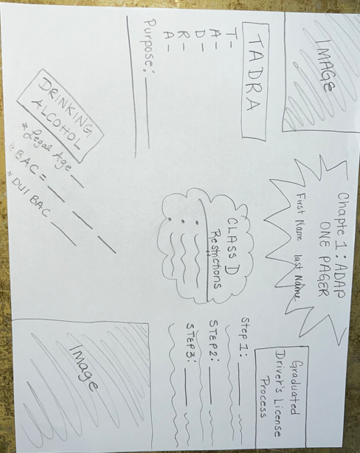
March 8th: asynchronous
March 7th: substitute/gym
March 6th: Block Schedule
March 5th: Students shown plants & transplanting location (outside of media center), outside & gym

March 4th
Block Schedule A- Don’t

March 1:
Makeup day for major grades:
Black History Project
SMART goal quiz
Feb 29:
-Henrietta Lacks word search
-5 sentence summary using at least five terms from the word search explaining how the History of Henrietta Lacks relates to health. Keep in mind the three dimensions of health & include those within the summary. Use specific examples in the summary.
Feb 28: Black History Project due
Last day for students to work on Black History Project Choice

Feb 27: substitute
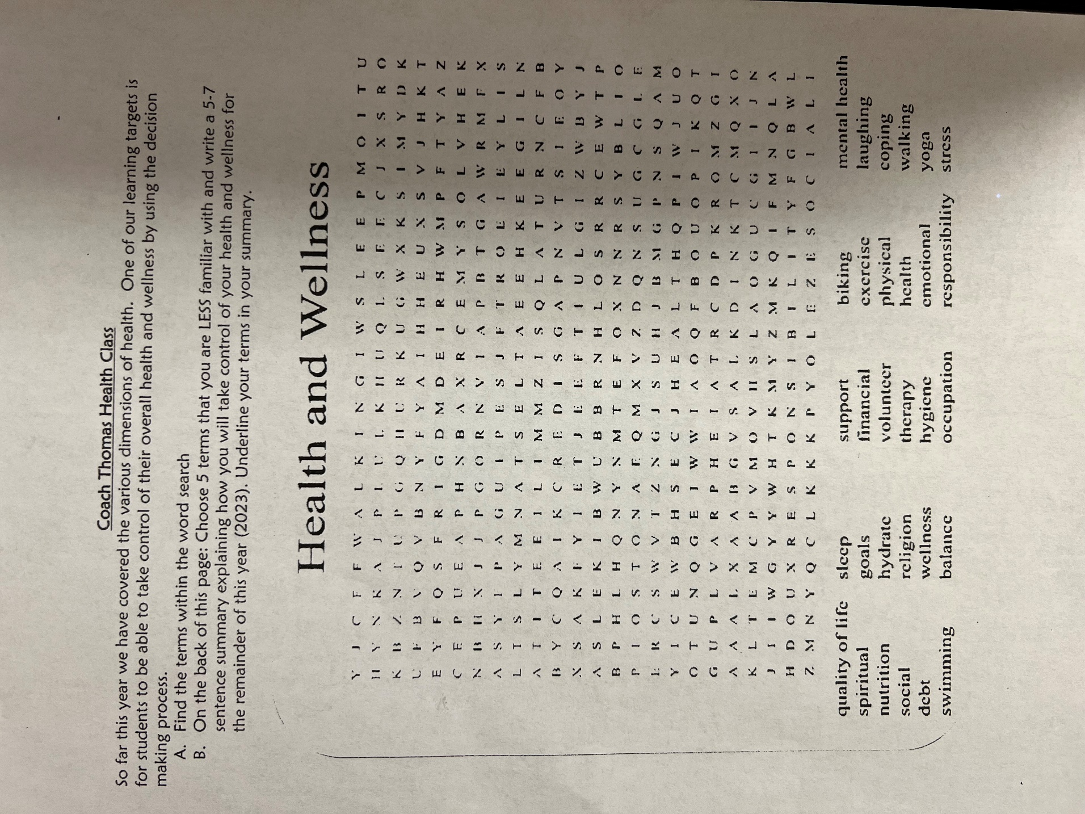

Health & wellness word search
Feb 26 Monday
Students given time to work on Final Project (even if rough draft was not done)
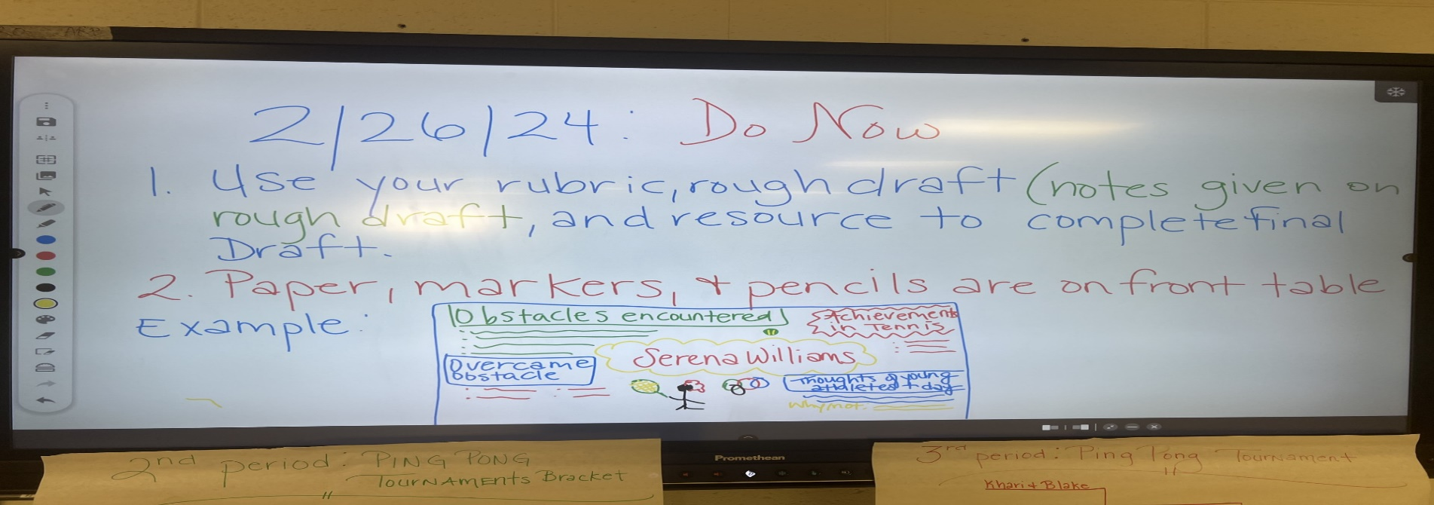

Feb 19-28 Black History Project
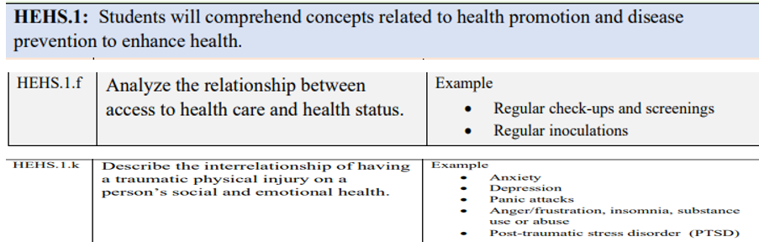
Learning Targets:
- I can explain the significance of African American’s role in health, sports & physical education
- I can describe the way that Henrietta Lacks played a role in the development of medical treatment for cancer

Success Criteria: I can
- I can present information regarding African American figures that have made history and/or paved the way for future generation by explaining their struggles and perseverance.
- I can explain what occurred to Henrietta Lacks and how that played a role in medical treatment today and why that is significant to Black History
Feb 23
Do Now: Feb 23
Take a picture of your rough draft to use while you complete the final draft
Turn in notebook
Classwork: Feb 23
Work on Final Draft of Project using rough draft using rubric/check off sheet

Feb 22
Do Now: None-work on rough draft
Classwork:
Rough Draft of final draft showing placement of where information will be on the paper, where your images will come from

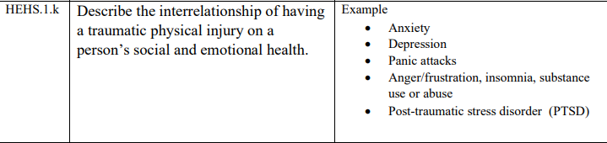
Feb 21:
Do Now: close read directions for Henrietta Lacks project (write and respond/provide the correct answer for each below)
- Topic of project:
- How many requirements are there:
- How many options:
- Which might you choose:
- How will you find information to complete the project:
Henrietta Lacks Project checklist/rubric:
Directions: Using the resources provided by Coach, research the information in the rubric. Decide which option you are choosing to do for your project (there are limited slots for each so let Coach Thomas know ASAP) and inform Coach Thomas to make sure that option is still available. Complete your rough draft in your notebook once you have completed your research. Then complete your Final Draft according to the expectations/examples provided by Coach.
** Options:
  - comic/story of timeline: One pager *Booklet (one page per requirement)
  - timeline *Video with props (script)-at least 1 minute
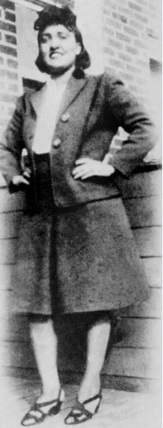
Resources:
https://www.nature.com/articles/d41586-020-02494-z
https://osp.od.nih.gov/hela-cells/
Requirements (for all options) | Check off | Possible Points | Points Earned
1.Background/Who was she? (2-3 sentences) |  | 20
2.Illness (how did she discover she was sick, what was the diagnosis?) |  | 20
3.What happened that was unethical (what was the outcome of her diagnosis and what occurred that was unethical within that process) |  | 20
4.At least two images (comic/story/booklet requires image on each page that has to do with the content) |  | 20
5.What does this have to do with black history? (what discrimination did Lacks encounter throughout her treatment process? would the situation have been handled differently with a white woman? Why or why not & if so, how?) |  | 20
6.How were her cells impactful to the world of medicine and people’s health (Be sure to include: How were Lack’s cells different? what are Lack’s cells called? why were Lack’s cells so significant?) |  | 30
7.What is the most recent use of HeLa cells? |  | 20
Total |  | 150

- Options:
  - comic/story of timeline One pager
  - timeline
  - Booklet – worth extra points
  - Video with props (script)

Resources:
https://www.nature.com/articles/d41586-020-02494-z
https://osp.od.nih.gov/hela-cells/

Henrietta Lacks Project checklist/rubric:
Directions: Using the resources provided by Coach, research the information in the rubric. Decide which option you are choosing to do for your project (there are limited slots for each so let Coach Thomas know ASAP) and inform Coach Thomas to make sure that option is still available. Complete your rough draft in your notebook once you have completed your research. Then complete your Final Draft according to the expectations/examples provided by Coach.
** Options:
  - comic/story of timeline: One pager
  - Timeline
  - Booklet (one page per requirement)– worth extra points
  - Video with props (script)-at least 1 minute

Resources:
https://www.nature.com/articles/d41586-020-02494-z
https://osp.od.nih.gov/hela-cells/
Requirements (for all options) | Check off | Possible Points | Points Earned
Background/Who was she? (2-3 sentences) |  | 20
Illness (how did she discover she was sick, what was the diagnosis?) |  | 20
What happened that was unethical (what was the outcome of her diagnosis and what occurred that was unethical within that process) |  | 20
At least two images (comic/story/booklet requires image on each page that has to do with the content) |  | 20
What does this have to do with black history? (what discrimination did Lacks encounter throughout her treatment process? would the situation have been handled differently with a white woman? Why or why not & if so, how?) |  | 20
How were her cells impactful to the world of medicine and people’s health (Be sure to include: How were Lack’s cells different? what are Lack’s cells called? why were Lack’s cells so significant?) |  | 30
What is the most recent use of HeLa cells? |  | 20
Total |  | 150

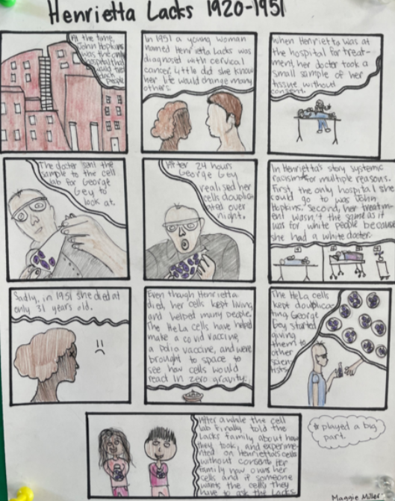

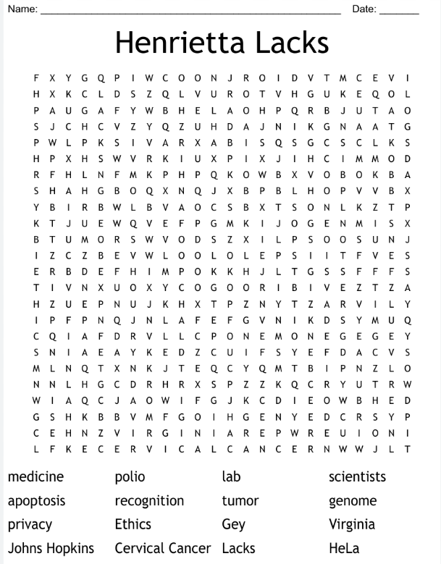
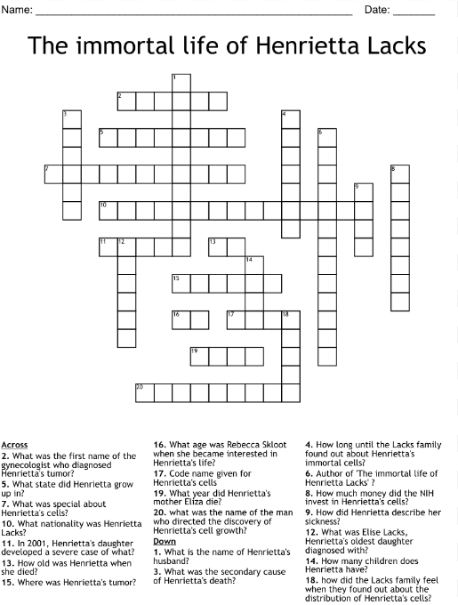

Classwork:
Research & record information in notebook

Feb 20: Asynchronous Complete missing work
Feb 19: Holiday

Feb 12th- 16th SMART goals & Black History Project Henrietta Lacks
Learning Targets:
- I can list the components of a SMART goal

Success Criteria: I can
- Develop a plan to achieve short and long term SMART goals

Do Now: Feb 15
Turn in your notebook if you have completed all of your assignments
Classwork: Feb 15
Vocab Quiz
Do Now: Feb 14
- What day is today?
- How do you feel about this holiday?

Classwork: Feb 14
- Peer Check using marker or color pencil: You are determining whether or not your partner has completed the assignment according to expectations from the video we watched, class discussion, textbook information, and examples provided
Do the following for each Letter of the SMART goal within the goal that your partner created for their seed: You should have a total of 5 images
- Smiley face if done correctly
- Frowny face if you know for sure it is done incorrectly
- Question mark if you think it is incorrect but you are not 100 % sure ?

Do Now: Feb 13
- List all of the assignments you had last week for this class
- How much time did you have to complete each assignment

Classwork: Feb 13
- Review of SMART goals video:
https://www.youtube.com/watch?v=wGbmAH4mBPA
WRITE 3 TAKEAWAYS
- Students given steps to success document for seeds when checked off
Do Now: Feb 12
- List the requirements of a SMART goal?
- What is your SMART goal for this class?
Classwork:
- https://www.youtube.com/watch?v=x_DA3dgRSrw&t=13s
: Stairs to success video takeaways (3)
- Feb 12 Seed Steps to success/goal rough draft
  - Image of vision for seed:
  - SMART goals for seed:
  - 3-4 Steps you will take to ensure you meet your seed goal

SMART Goal Steps to Success for Seed
Directions: Use the information from previous lessons/assignments, textbook pg. 39, and example provided by Coach to complete this assignment. Draw an image below the eyes of how you expect your seed to turn out by the end of April. Create a SMART goal being sure to have all of the requirements. Use the same criteria for SMART, create at least 2 steps you will follow to make sure you reach your goal. We will fill in the SUCCESS box at the end of April/beginning of May.

SUCCESS (April 2024)

ACTION PLAN
SMART Steps
1.___________________________
_____________________________
2.___________________________
_____________________________
3.________________________________________________________



GOAL
Seed SMART: ____________________
______________________________________________________________

VISION

Draw an image of your
Vision for the seed you
Planted (below the eyes)
Week 6 Feb 5-9th
Learning Targets:
- I can list the components of a SMART goal

Success Criteria: I can
- Develop a plan to achieve short and long term SMART goals

Do Now: Feb 9- None
Classwork: Feb 9- work on missing assignments
Do Now: Feb 8
- List the assignments we had this week for classwork
- Put a check by the assignments you listed for number you that you actually completed
Classwork: Feb 8
- Review on quizziz
- Work on missing assignments

Do Now: Feb 7
- List three things you think are key to reaching your goals
- Write the following & fill in the blank(use page 40 in textbook for assistance)- Even if you do not achieve your goal you have set, the _________ of _________can lead to _____________ in the __________________.
Classwork: Feb 7 Complete missing assignments from this week

Do Now: Feb 6 In your own words
- What does it mean to value something
- List 2 things you value and explain why
Classwork: Feb 6
- Share out Do Now
- SMART goals assignment: heading
Directions: Be sure to write the heading for the assignment in the Classwork section of your notebook and follow the outline below along with the instructions provided by Coach. Additionally, use pages 39 & 40 in your textbook for assistance (NOT google or the internet)
- Health SMART goal: write out your SMART goal for this class using the Do Now from Jan 23
For each component below, provide justification that is in the goal itself that represents the requirements to qualify your goal as SMART: write it out as you see it below and provide the justification next to it
  - Specific:
  - Measurable:
  - Achievable:
  - Relevant:
  - Timely:
- Personal SMART goal: create a SMART goal that you would like to have accomplish by the end of April 2024 for your overall health.
  - Specific:
  - Measurable:
  - Achievable:
  - Relevant:
  - Timely:

Do Now: Feb 5
- What is your current grade in Health?
- What will you do to maintain or bring up your grade for Health?
Classwork: Feb 5 :
1.Quiz Review
Vocab: Chapter 2 terms: Create KIM Chart

K. Key term | I. Information (3 bullet points) | M. Memory clue (word, phrase, image, etc.)
Example: Health | - Lack of disease  - wellness  - multi-dimensional | Social  Emotional  physical

1. values
2. SMART goals
3.health literacy
4.pseudoscience
5.life long learning
6. consumer
7.food and drug administration
8. advocate
9. preventative healthcare
10. food desert

Week 5
Learning Targets: I can
- Define health, wellness, and well-being
- Analyze how physical, mental, social, and emotional health dimensions are interrelated
- Explain the status of health as it relates to a continuum
- Describe the impact that behavioral choices and lifestyle have on health and wellness
(The complete well-being (which is health) of plants : Wellness is the process of identifying one’s state of health and taking steps to improve it. The success/longevity of the plants rely on this just as the human body)
Feb 2:
Do Now: Feb 2 none
Classwork: Feb 2 if you missed turn in missing work & plant care and/or plant seeds
Feb 1:
Do Now:
- Has your plant sprouted yet? (If you do not have a plant, put that you have not planted your seed)
- Draw an image to show current status of your plant
Classwork: same as previous day
Jan 31
Do Now: Jan 31
- When is the last day to turn in any assignments that have not been completed?
- What is your current grade for Health?
Classwork: Jan 31
Complete any missing work
- Ch.1 Vocab KIM
- Dimensions of Health chart
- Dimensions of Health summary
- Plant Journal
- Do Now assignments
TURN in notebook when all is complete

Jan 30
Do Now: Define the following in your own words
- Germinate
- seedling
Classwork:
- quizziz review
- making connection to plants wellness & our own wellness (class discussion)
Jan 29
Do Now: Jan 29
1.What is your current grade in Health?
2. What help do you need at this time in Health class?
Classwork: Jan 29
Begin Plant Journal in the back on notebook (last 12 pages in notebook)
- Fold the 13th page from the back as your divider for your Plant Journal
- On the next page complete the following
  - First seed tracking Info: heading
  - Date planted: January 18th 2024
  - See planted:
  - Steps taken to plant seed (at least 4)
  - Material used (plastic cup/half a recycle water bottle, soil, seed)
  - Care steps as of today
    - watered
    - Covered (to seal in moisture & heat until germination)
    - Light provided to sprouts

Week 4
Jan 26: gym
Jan 25
Do Now:
- What type of seed did you plant?
- List two things you have done so far to care for your seed.
Classwork:
Plant viewing and explanation of care

Jan 24
Do Now: Jan 24-use same sheet as yesterday
In your own words, define the following
- Health
- Wellness
Classwork:
- Review of Do Now
- Video & summary
- Complete work from previous day (extended time & assistance from coach)

Do Now: Jan 23
Write the following and wait for further instructions with completing the sentence
- My goal is to accomplish the following by the end of the semester for Health class:
Classwork:
Heading: The Dimensions of Health Chart

Type of health | Description | 2 Methods (activities) to promote health
Physical
Emotional/mental
Social

Summary on same page
Video of dimensions of health: https://www.youtube.com/watch?v=ijpvLaArBBI
- Write a five-sentence summary explaining how these dimensions of health are interrelated (what does one have to do with the other? How does the care or lack of care of one or more impact the other/s specifically? Describe and use examples to further explain)
- Check on seeds and water

Week 3
Jan 18th
Do Now: planting seeds video
Classwork:
- Coach review expectations for students’ individual seed planting
- Students add soil, label container & plant seeds (options: cabbage, tomato, sage, jalapeno, and spinach)
Jan 17th
- Review of notebook setup
- Students given more time to complete Ch.1 Vocab KIM chart
Do Now: Jan 16
- Notebook setup lead by teacher
  - All work must be in your notebook for this class to receive credit
    - Name & period on cover
    - First page blank
    - 2nd page Table of Content
    - 3rd page About Me
    - 4-24 Do Now assignments (1 week per page for full credit)
    - 25-Divider for classwork
    - 26 blank
    - 27-remainder Classwork
- Review of KIM chart expectations by coach
Classwork
Jan 16, 2024- Student will complete KIM chart for the following terms: chart should look like this
Heading: Ch.1 Vocab KIM chart Due: Jan 16th
K. key term | I. Info (3 bullet points for each term & no more than 6 words in this section-do not write out the definition) | M. Memory Clue- picture, word or words, pneumonic device
DNA
genes
Risk factors
Quality of health
Life expectancy
Well being

Exemplar/Example:
K. Key term | I. Information (3 bullet points) | M. Memory clue (word, phrase, image, etc.)
Example: Health | - Lack of disease  - wellness  - multi-dimensional | Social  Emotional  physical

Week 1 assignment
Assigned on Jan 4, 2024: Due Jan 5
Instructions: Use the expectations PowerPoint that you can locate on Coach Thomas’ teacher page from the Westside school website: Write the question and answer-follow the guidelines provided in each question for full credit.
- Using a complete sentence, summarize the second bullet point for the mission statement.
- Based on the grading policy, list two things you must do to pass this class.
- True or False: If you are absent that means you do not have to complete the work that was done on the day you missed?
- Who is in charge of your grade for this class?
- List the process a student must follow once they have entered the class (list a least 4 steps)
- Fill in the blank. Remember No _____________ ___________, ___________________ or ___________________________ _______________________ allowed while waiting for teacher.
- In order to touch, play with, or do anything to items that are not yours, what should you do?
- Fill in the blank. A ____________________ __________________ is everything.

